1. 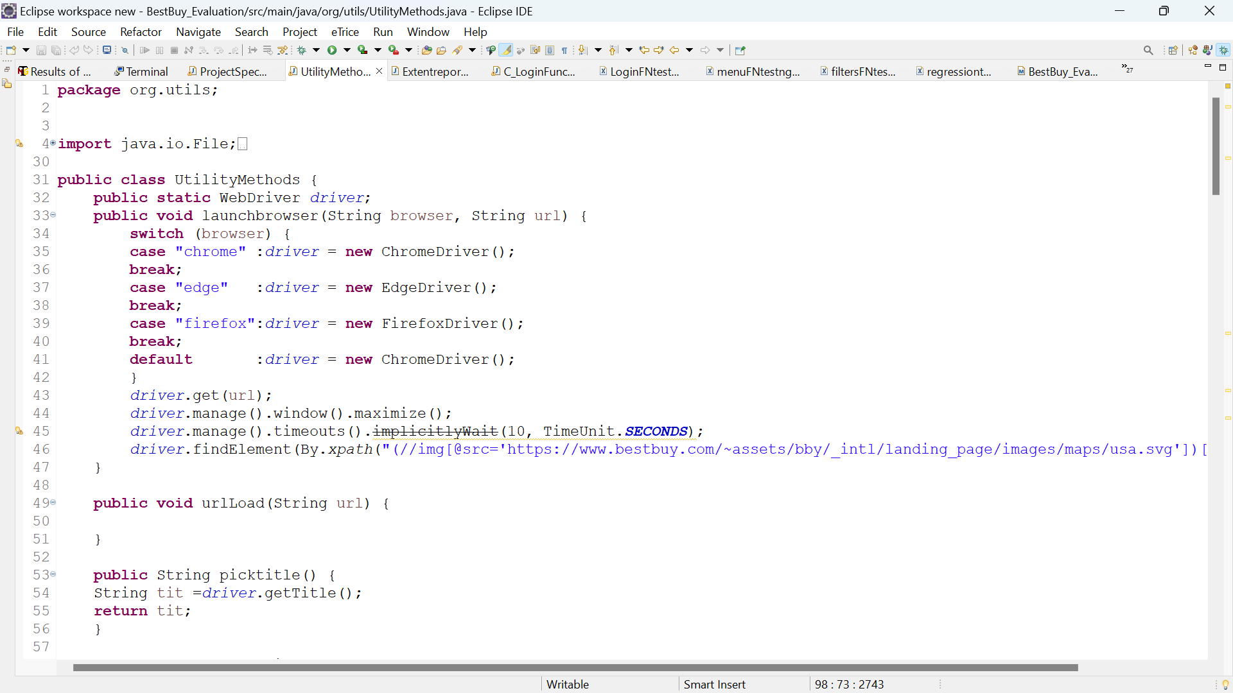Write code to open a web browser and navigate to the Best Buy e-commerce website

* Here I wrote the code for launching the browser and open Best Buy e-commerce website
* For cross browser testing I used switch cace function and I gave multiple browser as case like

Chrome browser, Edge browser, firefox browser

* In case there is any spelling mistake means it will launch chrome browser as default
* 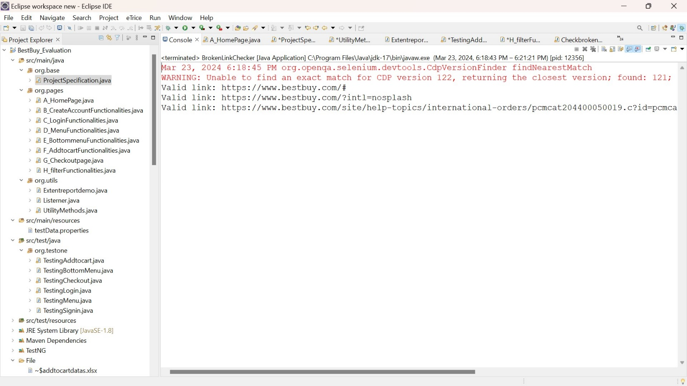Type of broser and url get from testng.xmlfile where I have maintain parameters like url and type of browser

1. 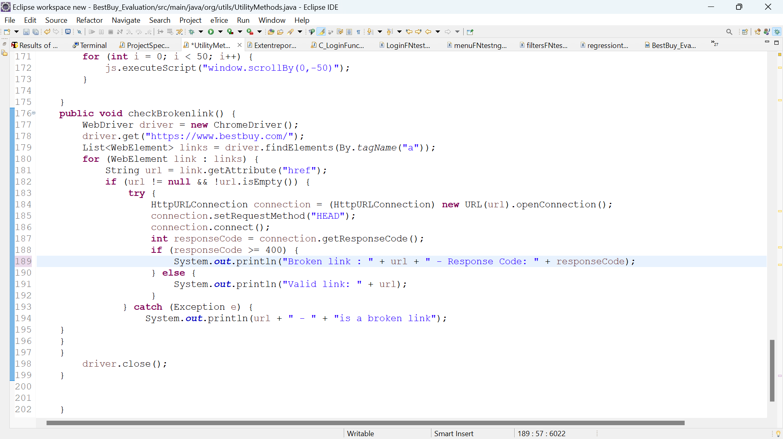Write a code to validate if the given URL Link is broken.

* Here this method is used to find the given url is broken url or not
* so my test is given url is broken or not or to find if there is another links or broken in the website
* I did the test wether the link is broken or not

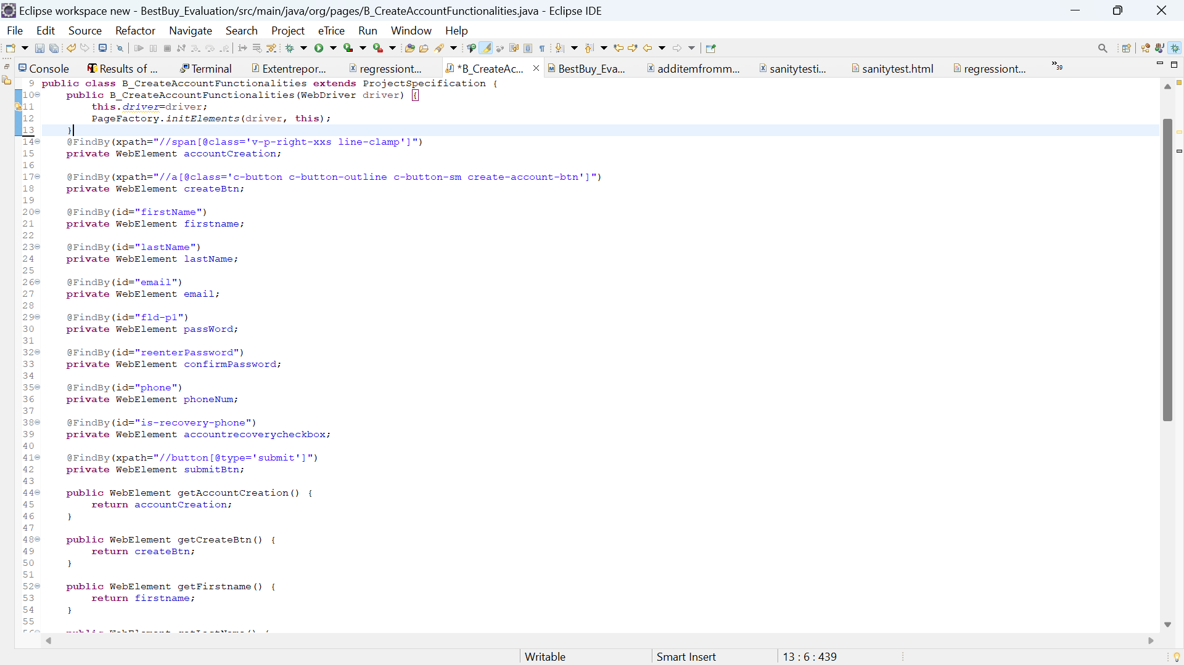3. Write a code to do Sign-Up and Login functionality.

* Here the signup functionality code is present so I used Page object model for each pages in project And I had use @FindBY annotation
* This annotation is used instead of driver.findElement we can find the element using @FindByAnntation
* And all the elements given as private web element
* And I have added getters for that private webelement

1. 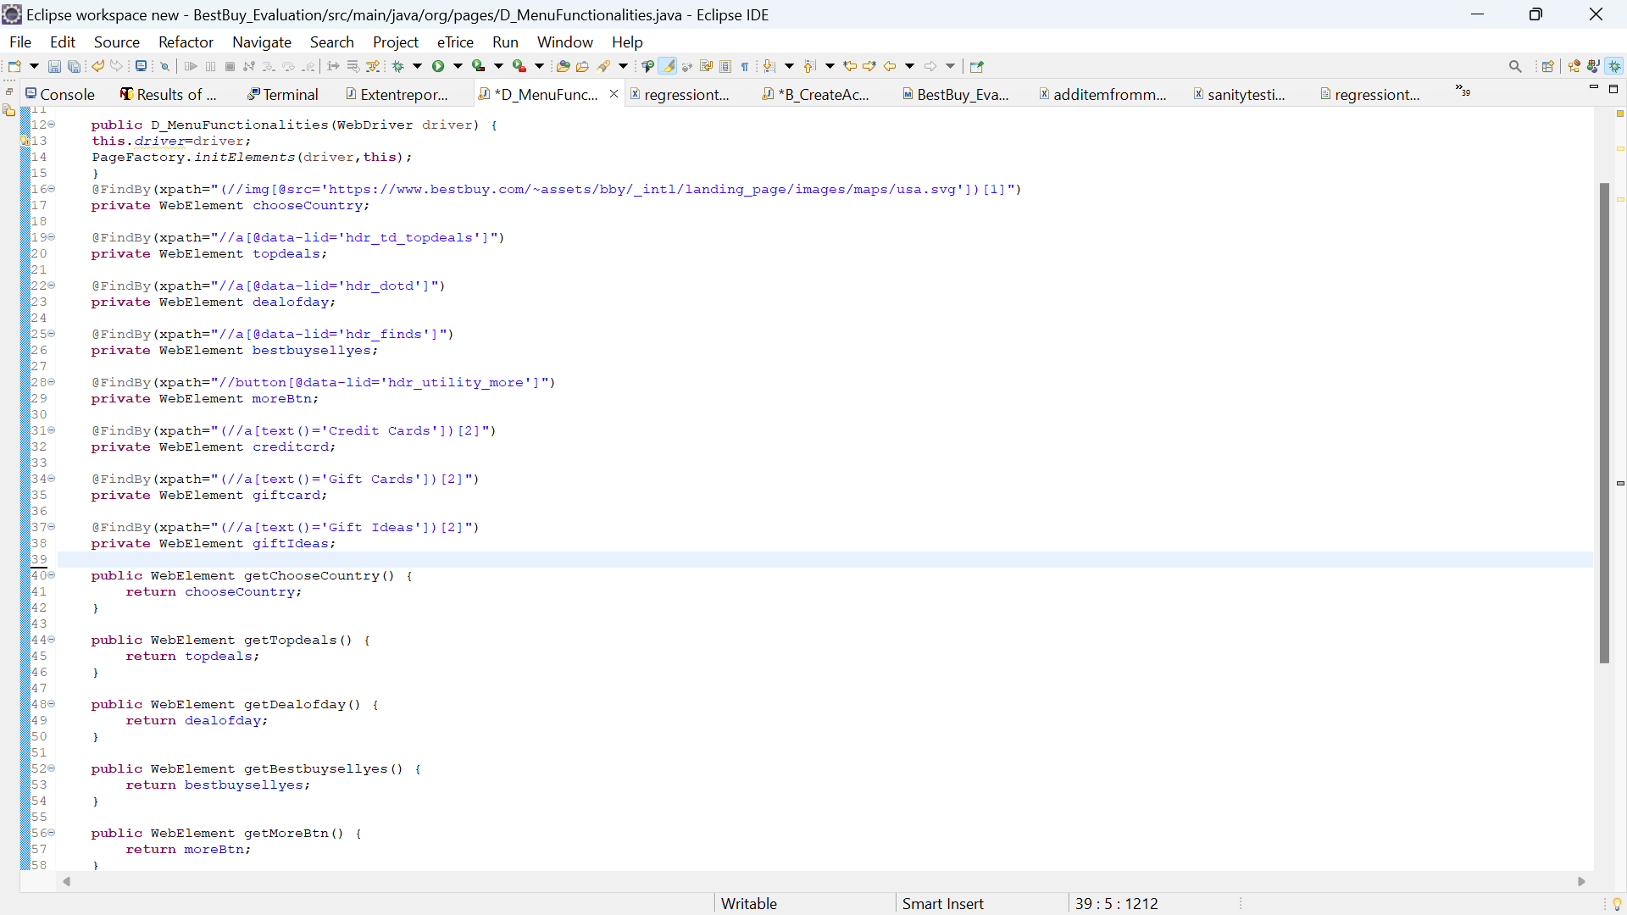Write a code for navigation of all Menu and validation of title

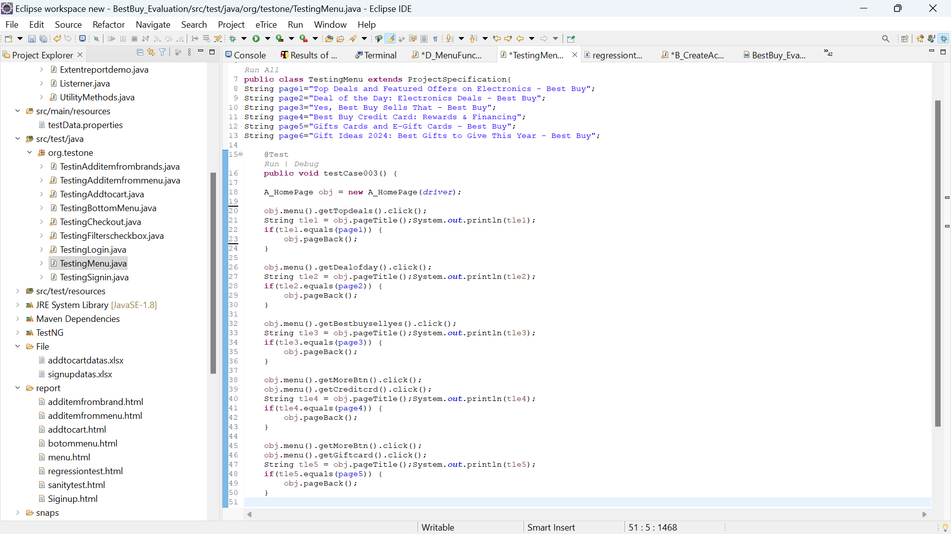i write the code for click all menu options and each menu options has separate page so it has page title and I get the title from each page and compare original title so in this way I evaluate the menu options

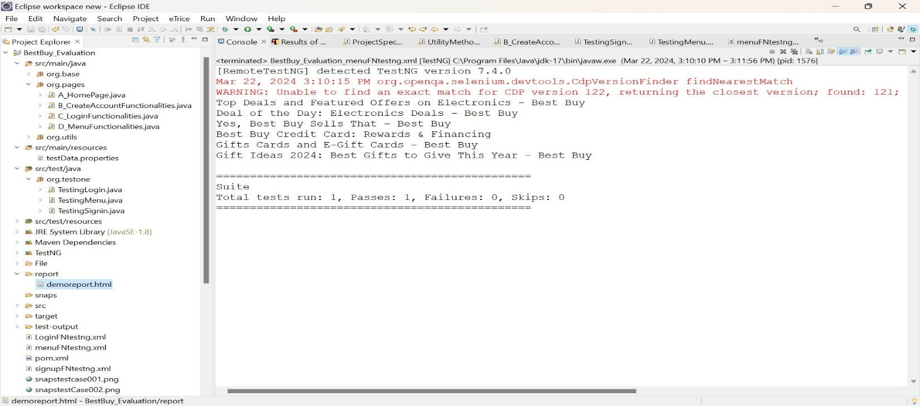Output

1. 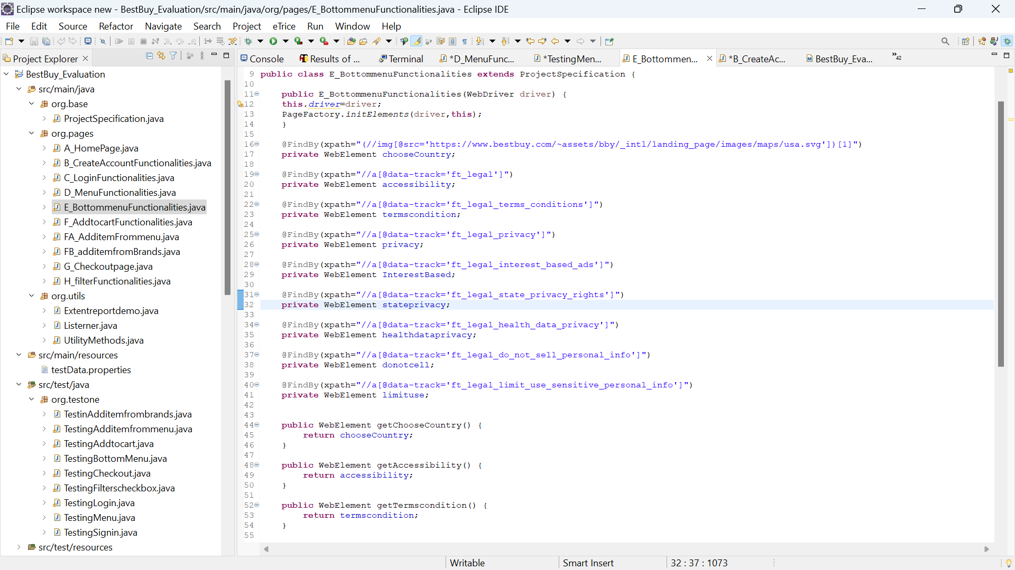Write a code to validate the bottom links on the homepage.

* For checking the bottom menu list I have used the same way what I used in menu testing
* First I create repository for storing all the webelement for bottom menu web page
* And I will give getters to get the element where I want to use
* And get the page title and I will compare what I have received from selenium both are equals

Means then it go for next menu options.

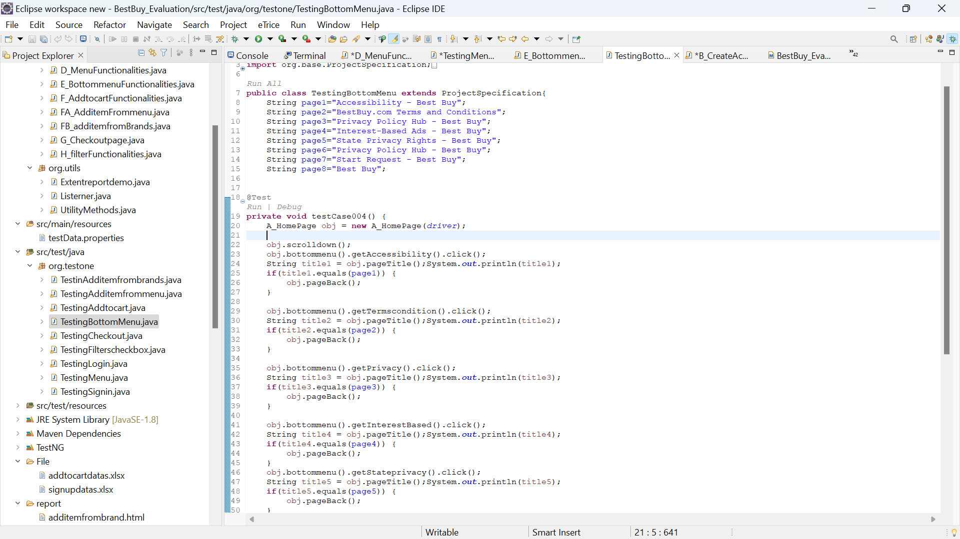

Output:

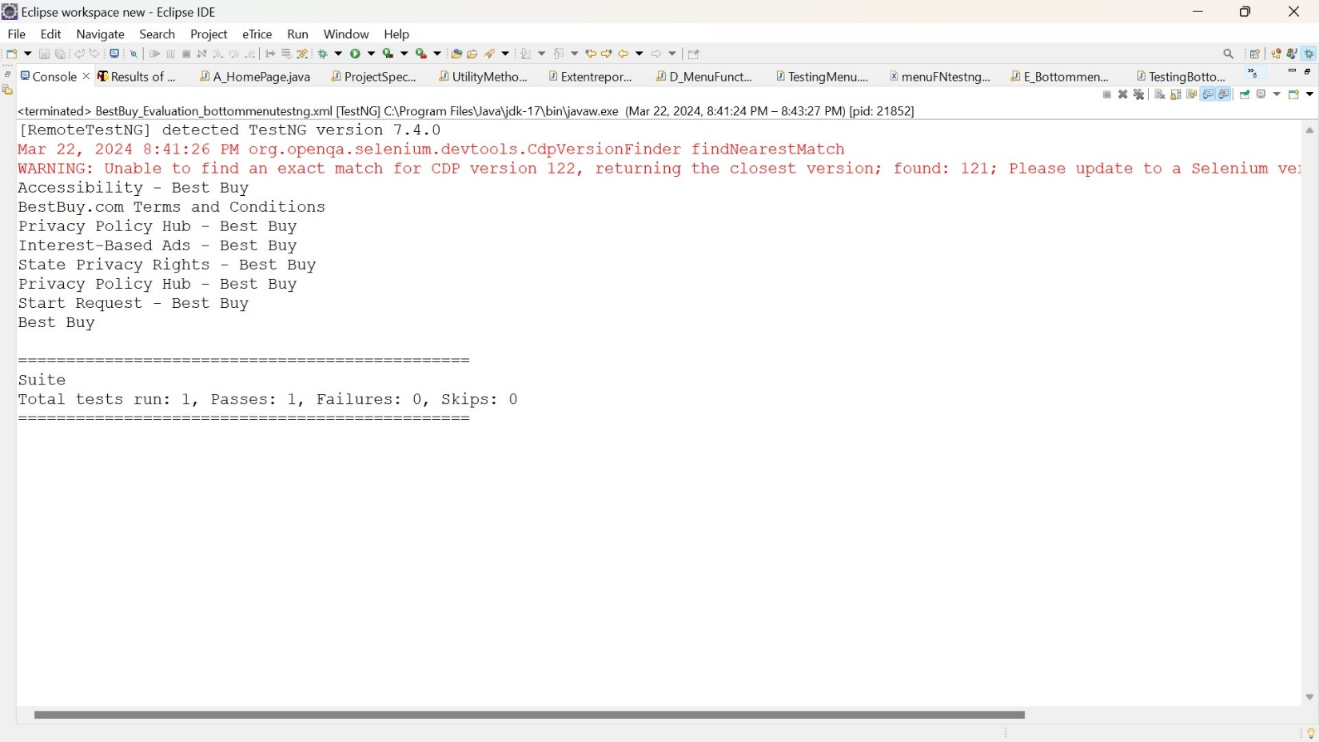

1. 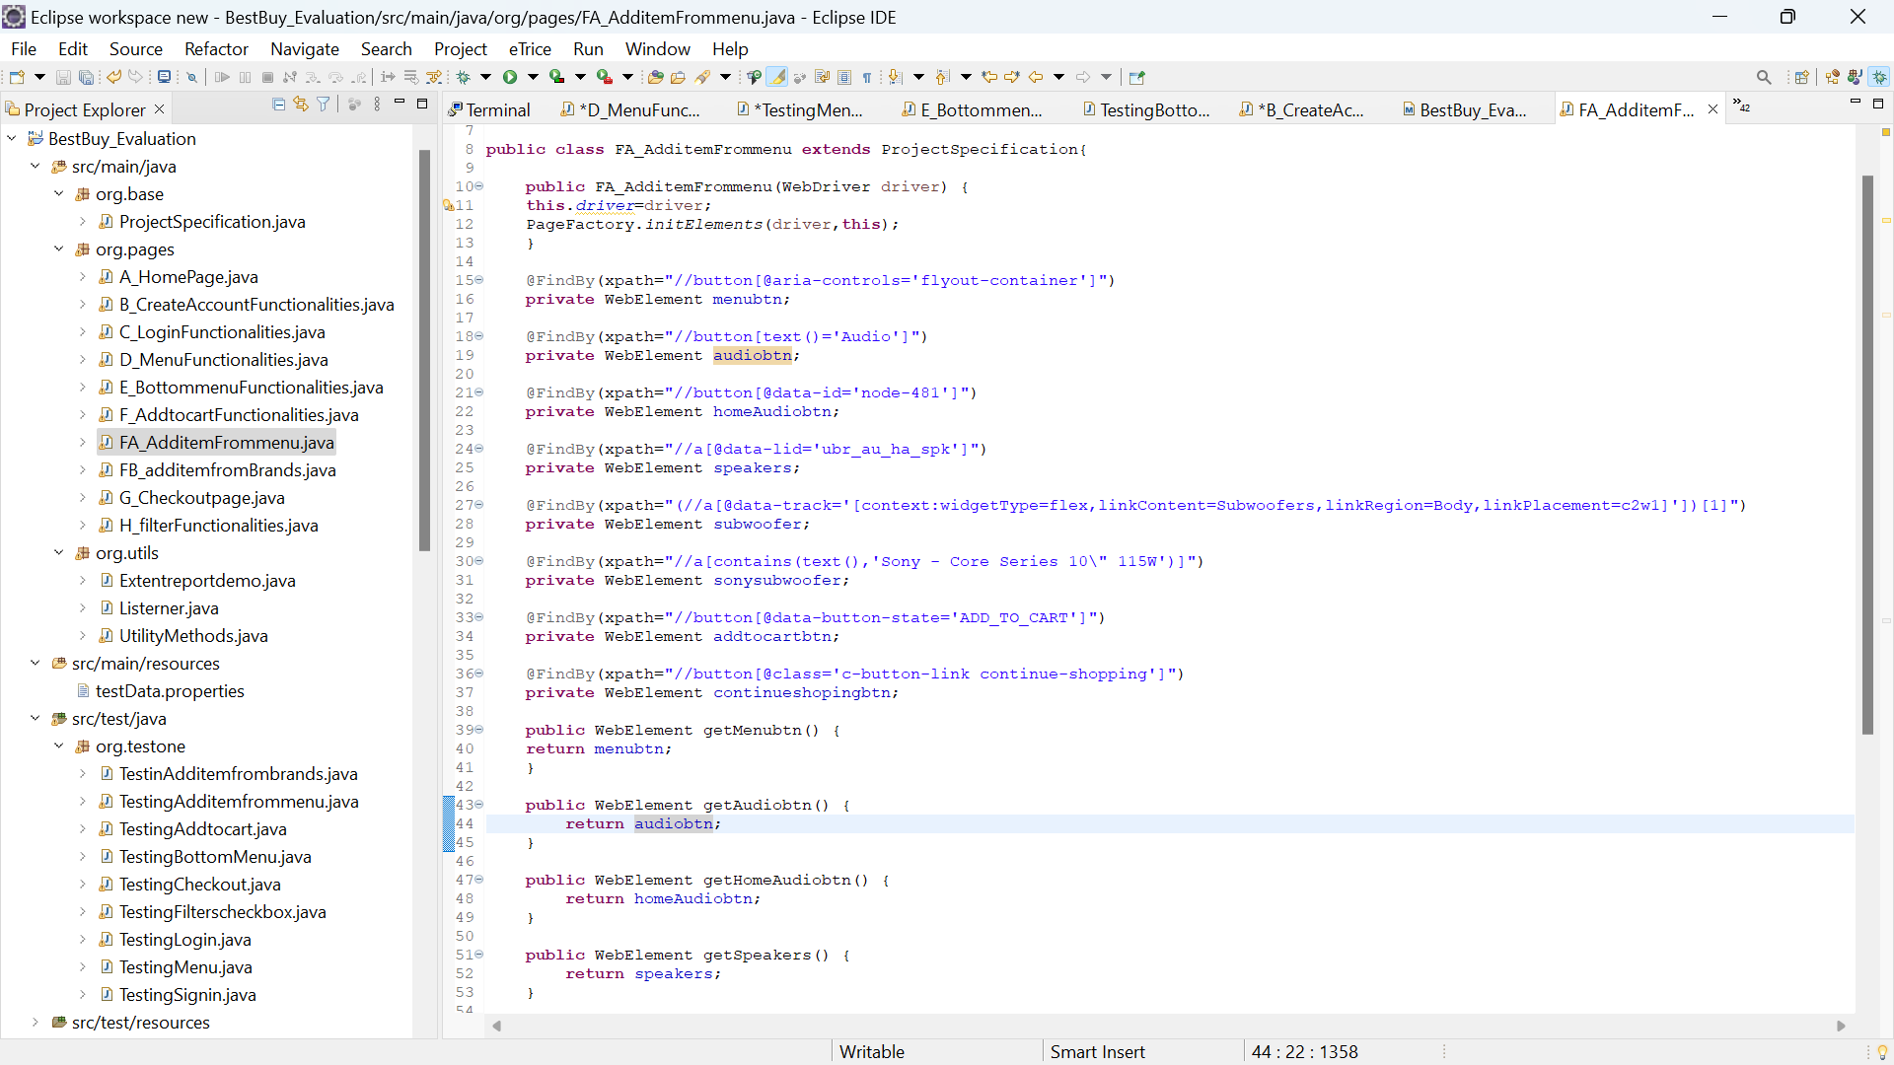Write a code to select and add an item from (Menu à Shop by Department.

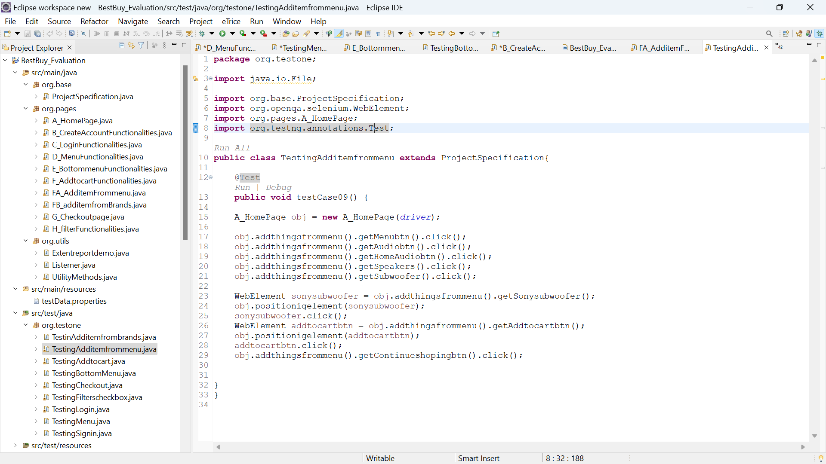

1. 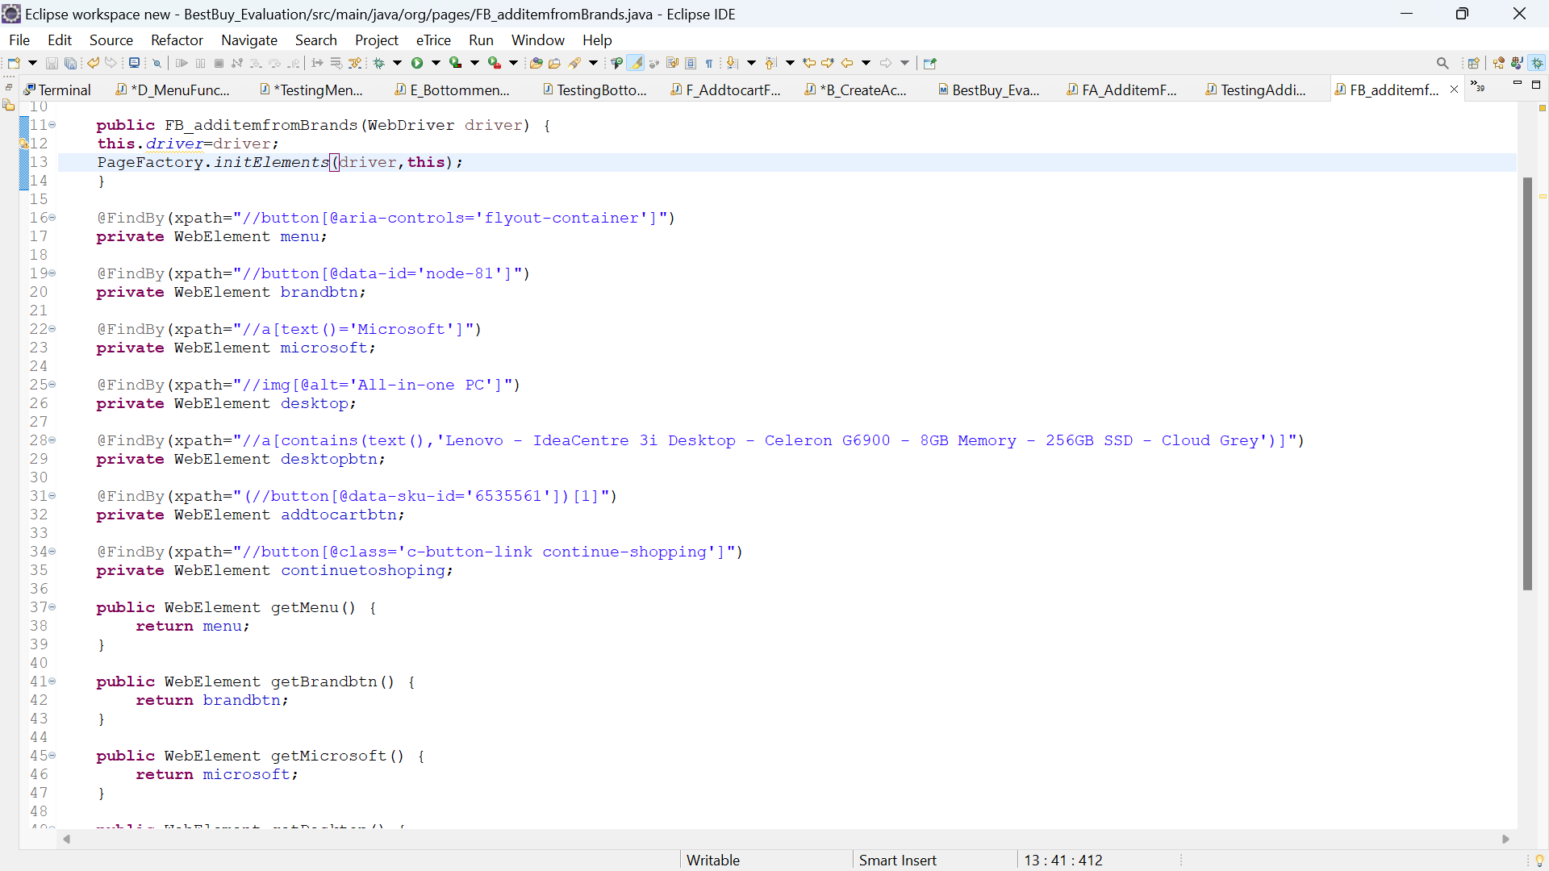Write a code to select and add an item from (Menu à Brands à Select Any Brand).

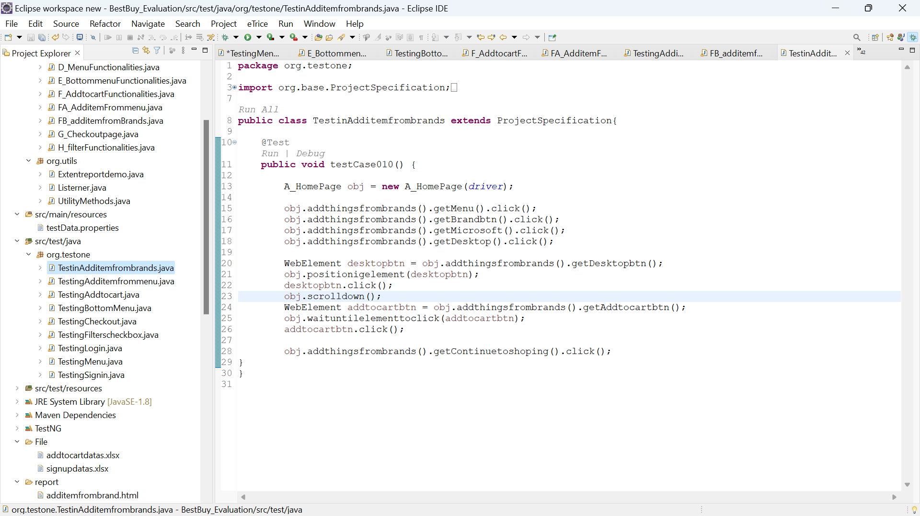

1. 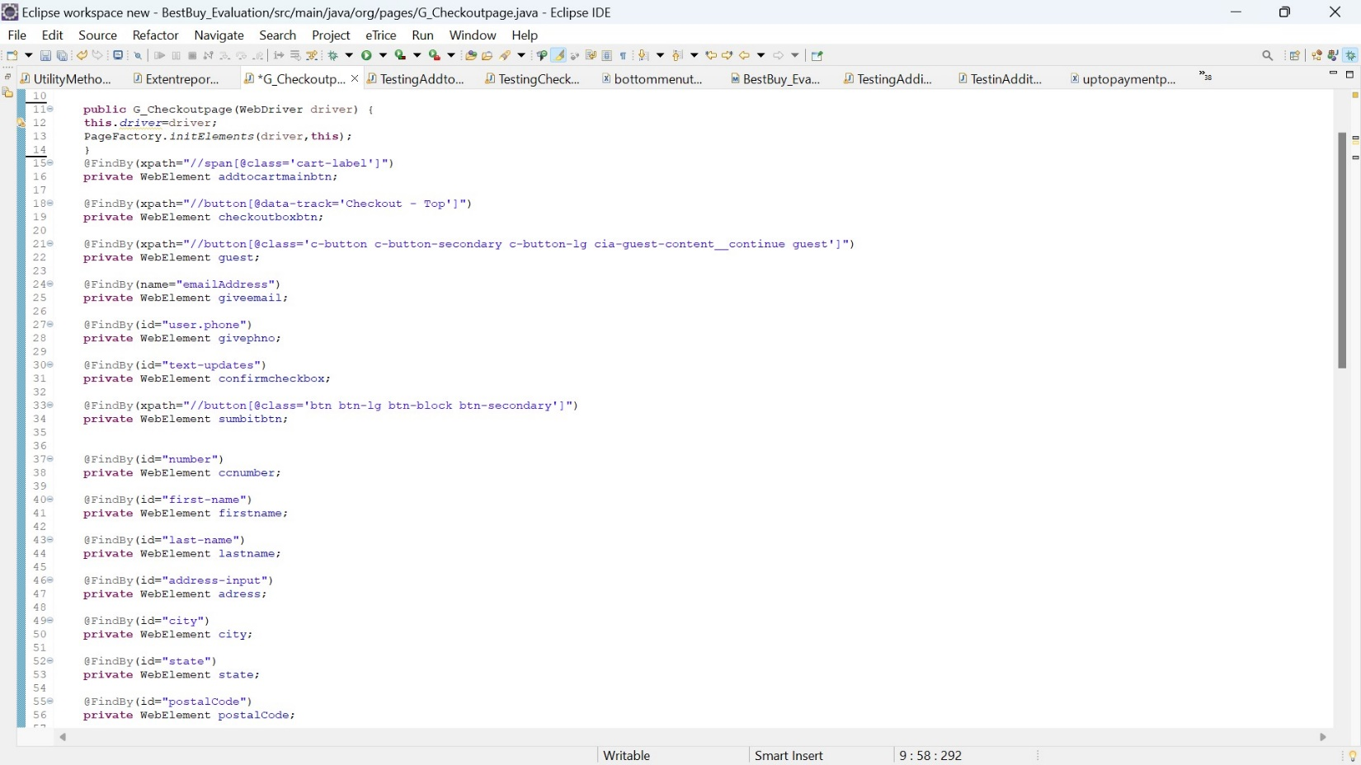Write code to navigate to the checkout page and fill out the form with dummy payment information

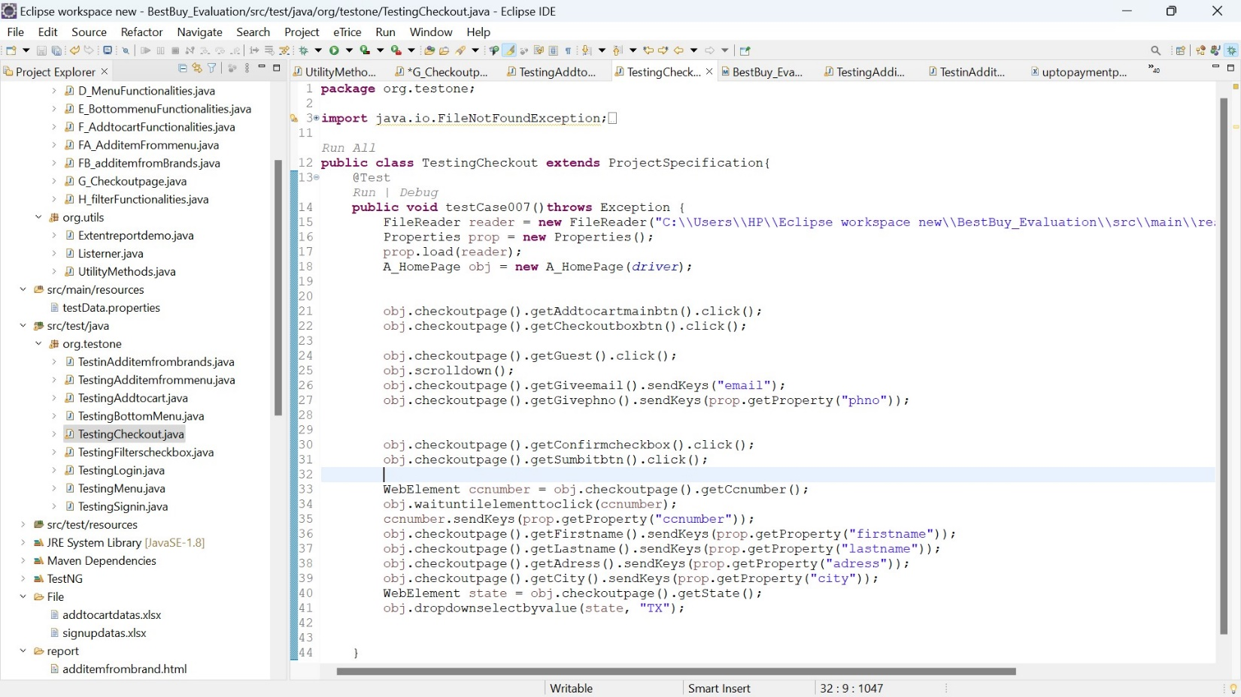

1. 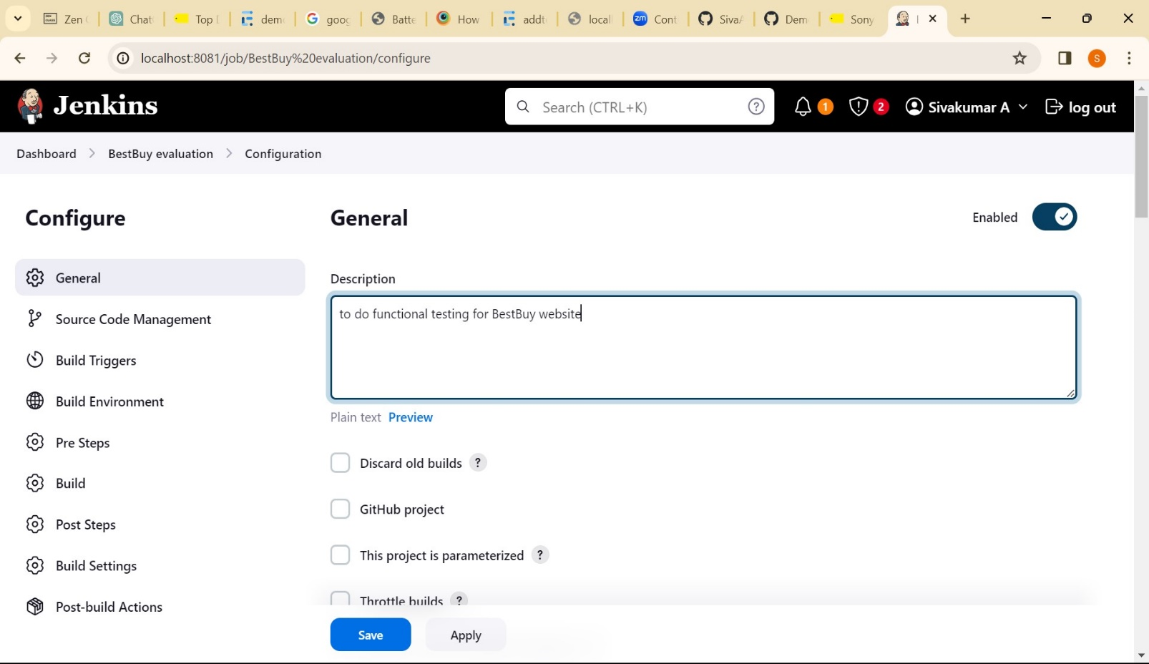.Write code to run the test suite automatically on a regular basis (e.g., once per day).
2. 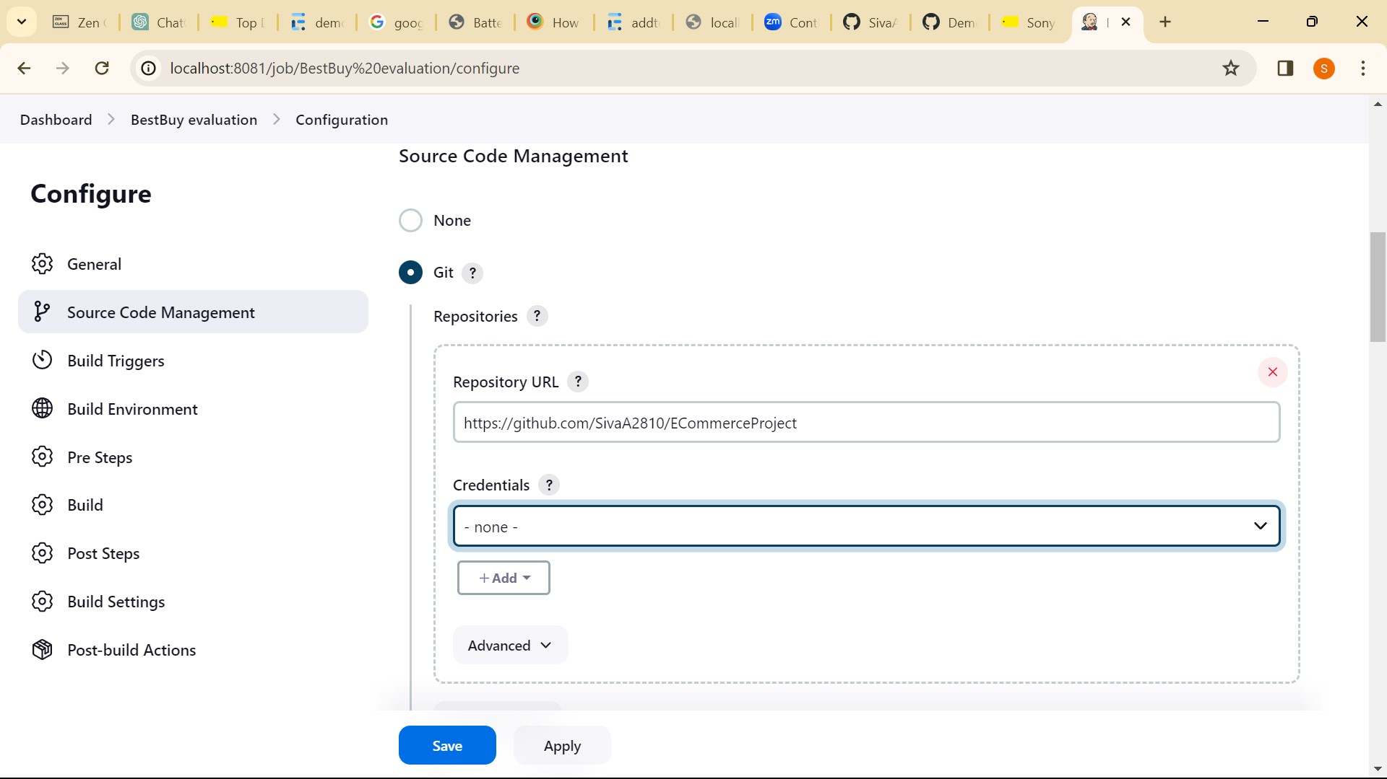

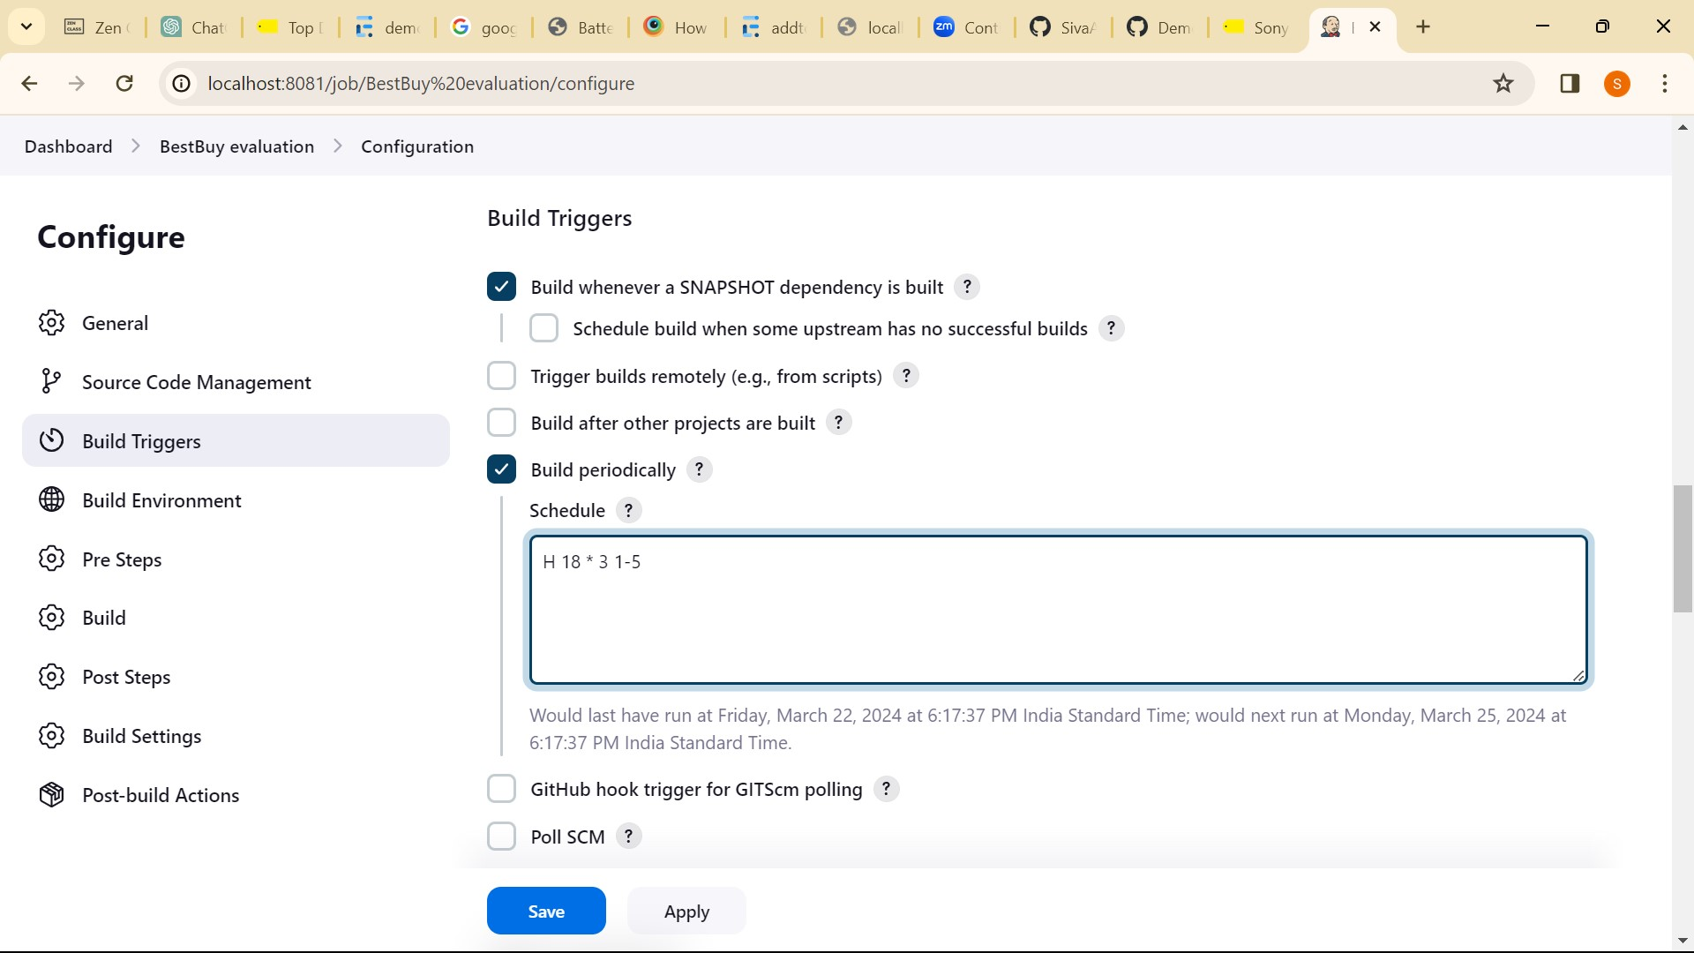

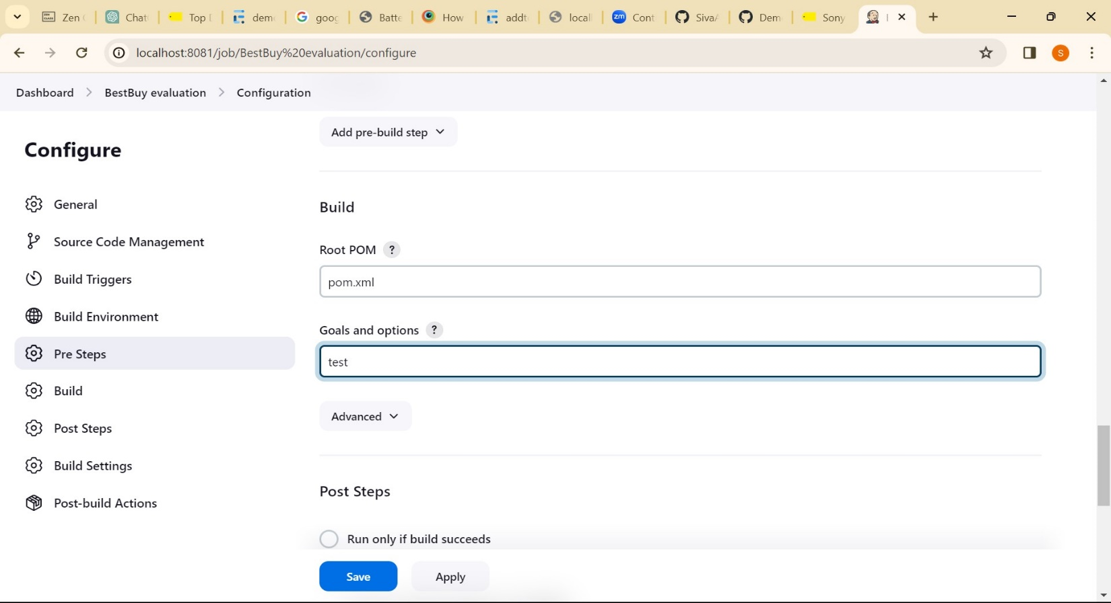

1. 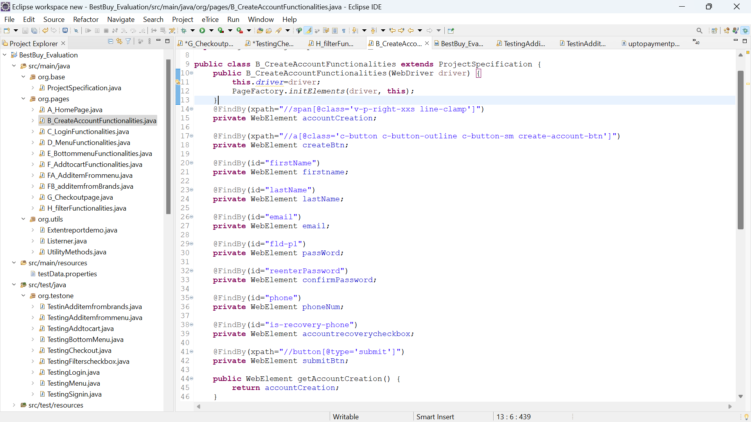Write tests to cover as much of the functionality of the Best Buy e-commerce website as possible, including searching for items, filtering search results, and creating an account.

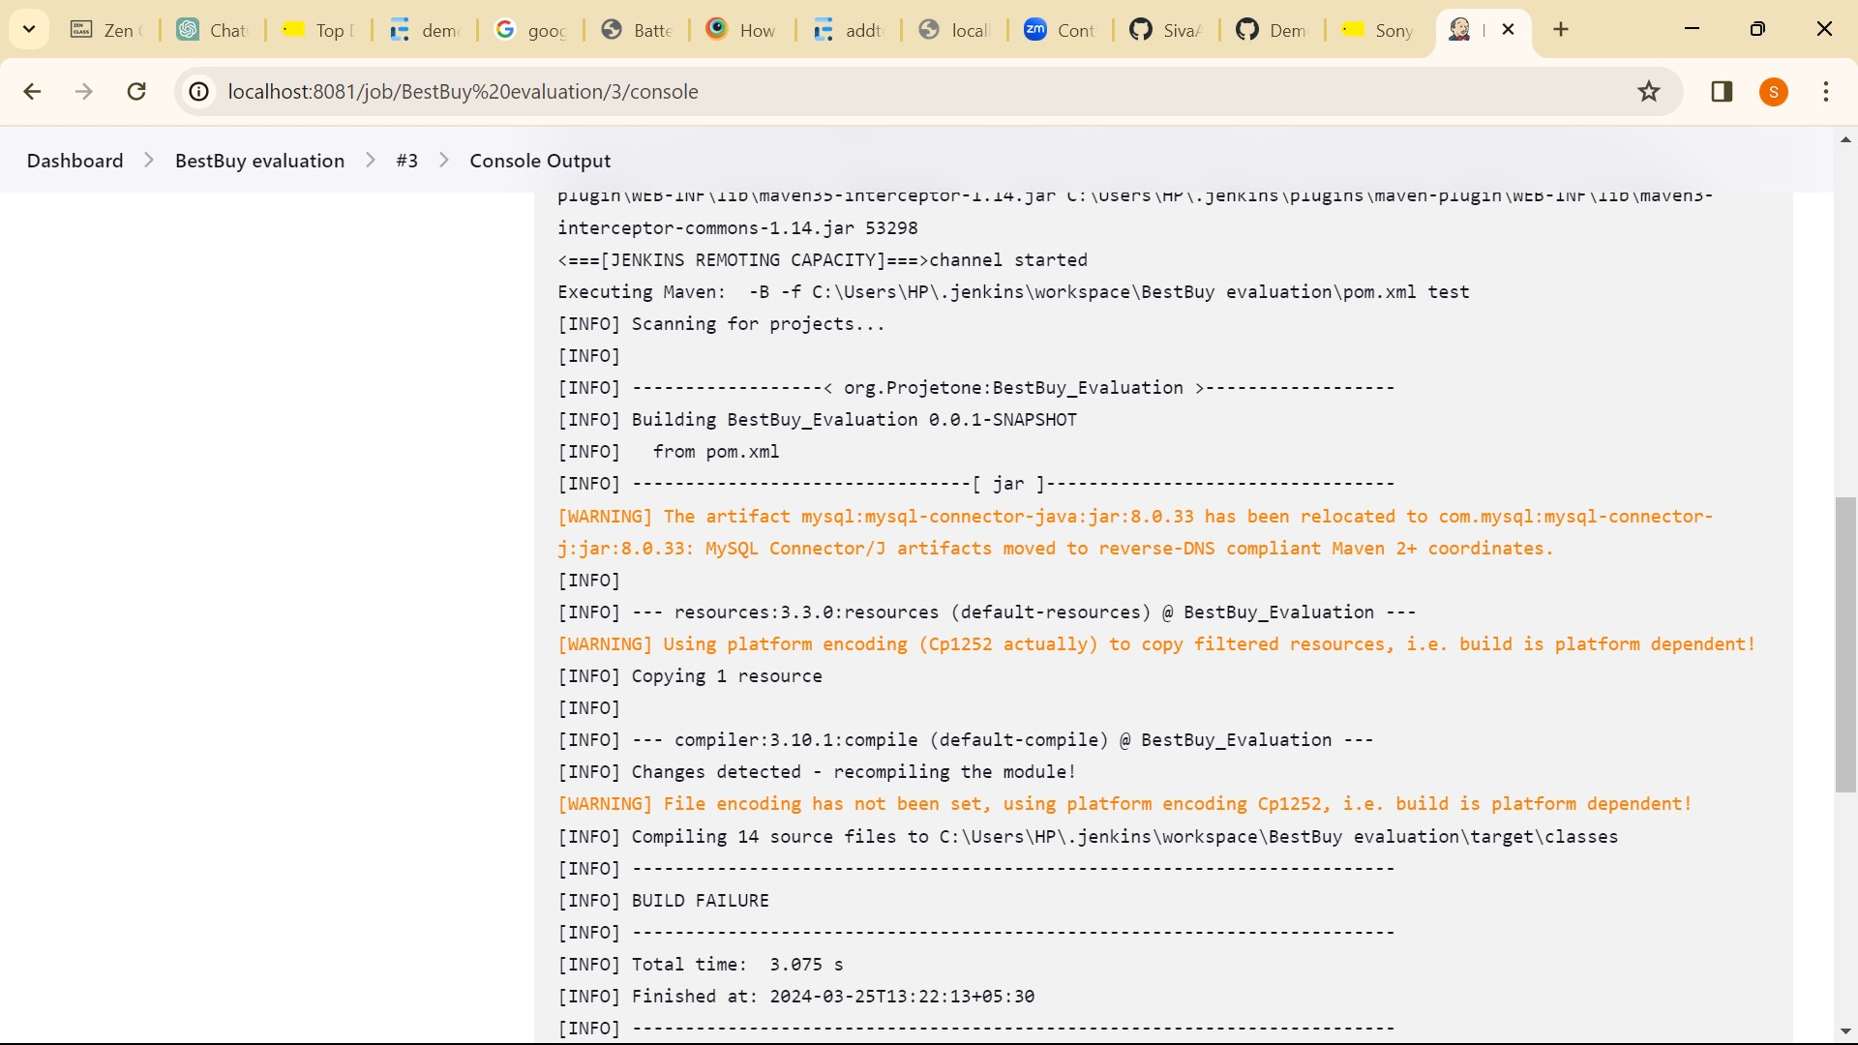

Reports :

Addtocartandcpayment - <file:///C:/Users/HP/Eclipse%20workspace%20new/BestBuy_Evaluation/report/addtocart.html>

buttommenu fntis - <file:///C:/Users/HP/Eclipse%20workspace%20new/BestBuy_Evaluation/report/botommenu.html>

menufunctionalities - <file:///C:/Users/HP/Eclipse%20workspace%20new/BestBuy_Evaluation/report/menu.html>

signup - <file:///C:/Users/HP/Eclipse%20workspace%20new/BestBuy_Evaluation/report/Siginup.html>

additemfrommenu - <file:///C:/Users/HP/Eclipse%20workspace%20new/BestBuy_Evaluation/report/additemfrommenu.html>

additemfrombrands - <file:///C:/Users/HP/Eclipse%20workspace%20new/BestBuy_Evaluation/report/additemfrombrand.html>

sanitytest - <file:///C:/Users/HP/Eclipse%20workspace%20new/BestBuy_Evaluation/report/sanitytest.html>

regressiontest - <file:///C:/Users/HP/Eclipse%20workspace%20new/BestBuy_Evaluation/report/regressiontest.html>

Testng.xml file

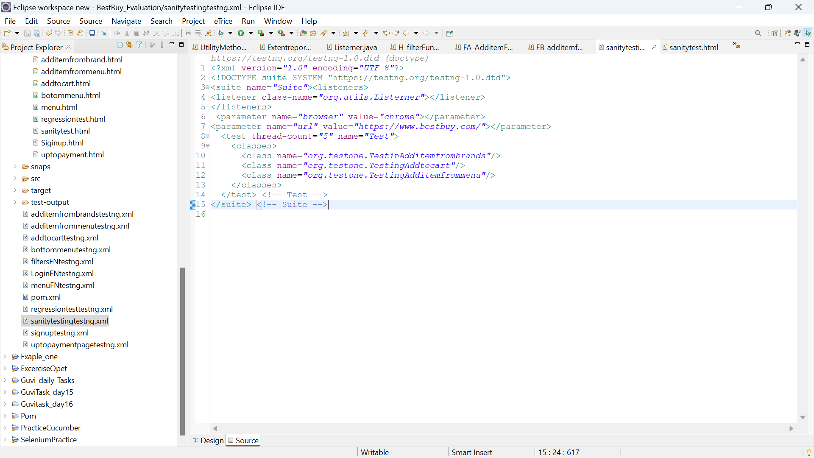Here I have mention one of the testng.xmlfiles like sanity test and regression test

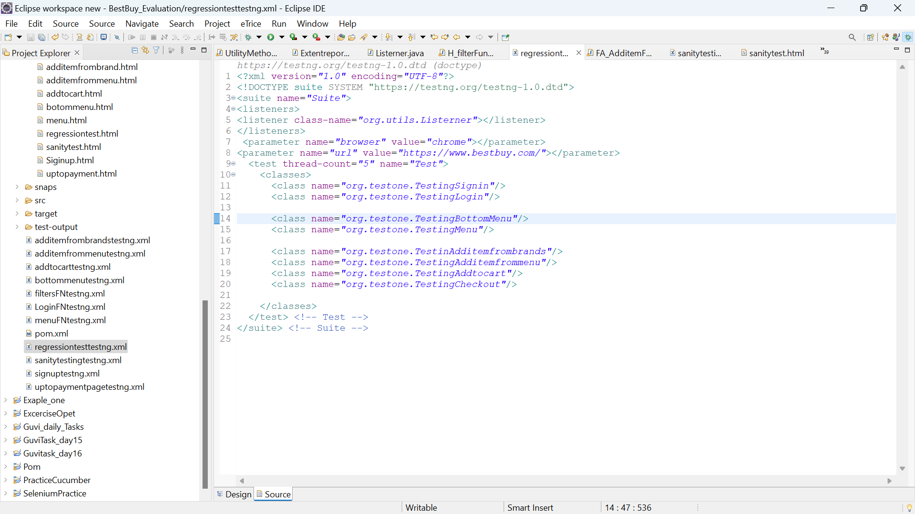

Example reports:

